I started by creating a slice
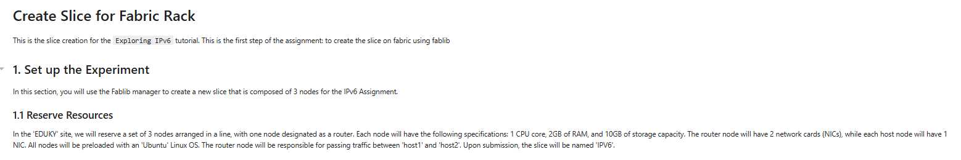
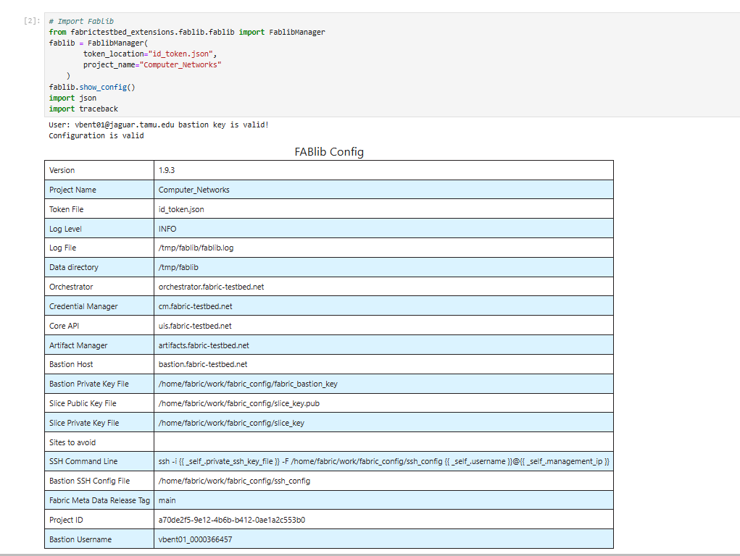

Then I gave slice name: VISESH_BENTULA_IPV6
And slice configs
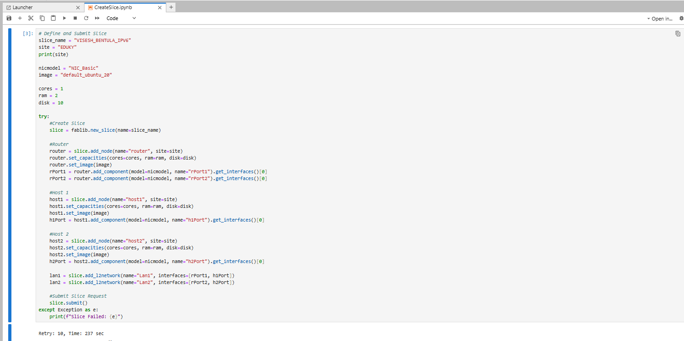
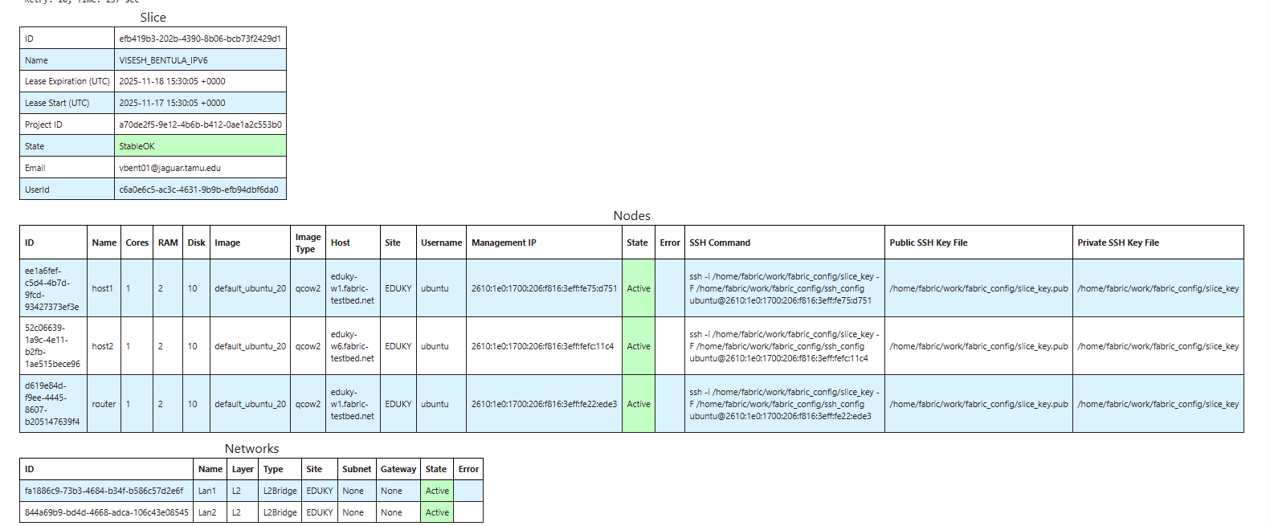
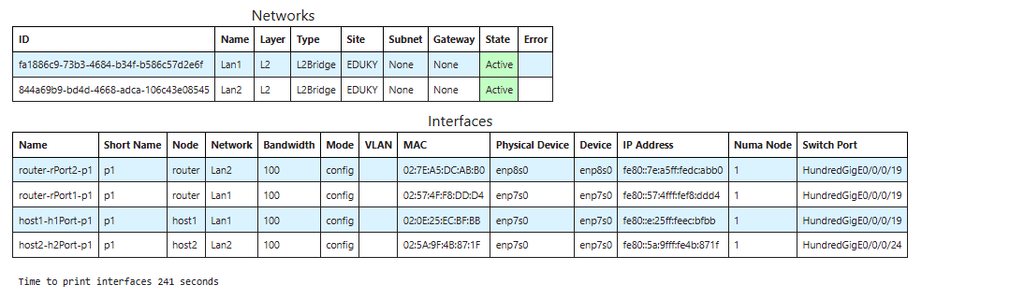
As you can see above the slice is created successfully and now I have to set up the network
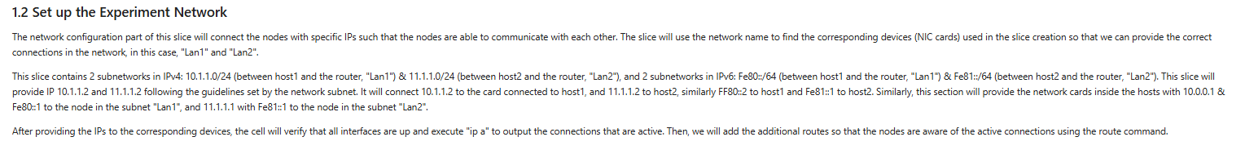
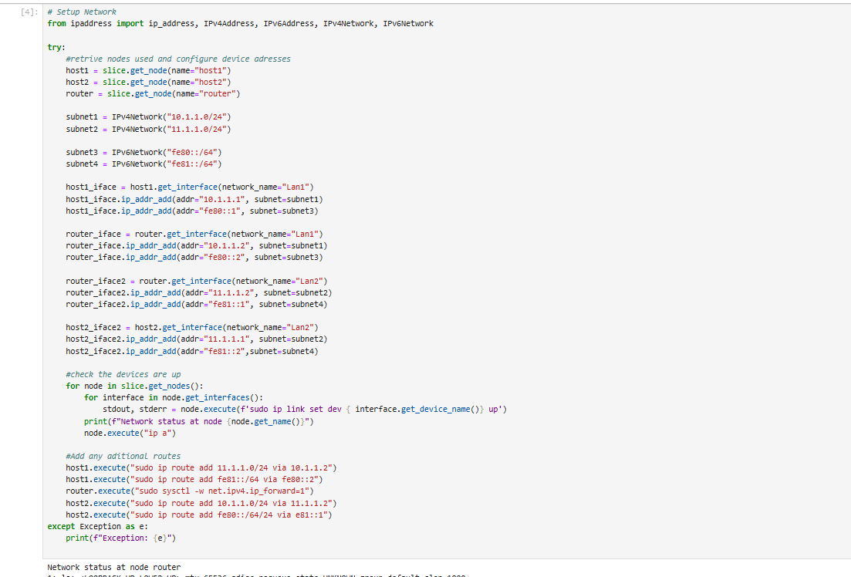

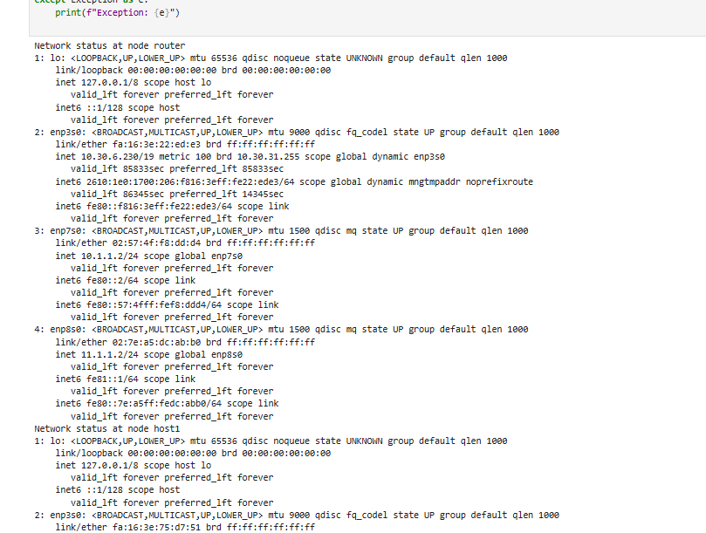
One the network is done setting up, now we install the software on each nodes required for the experiment
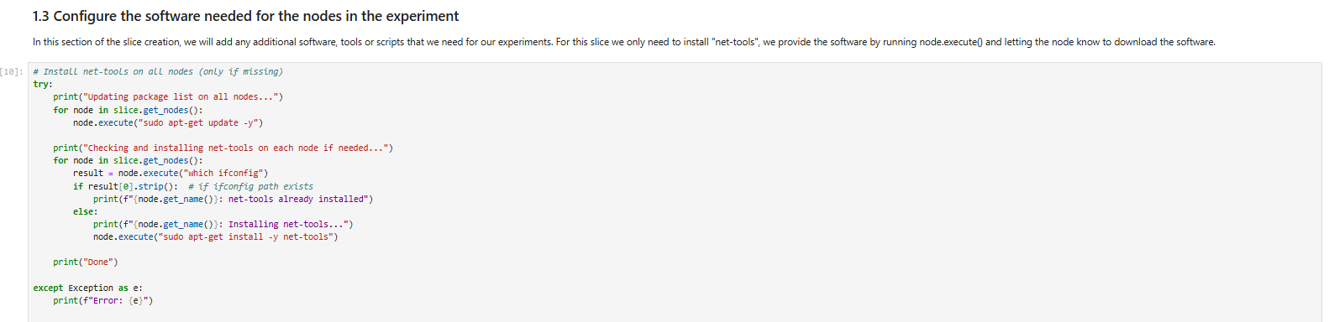
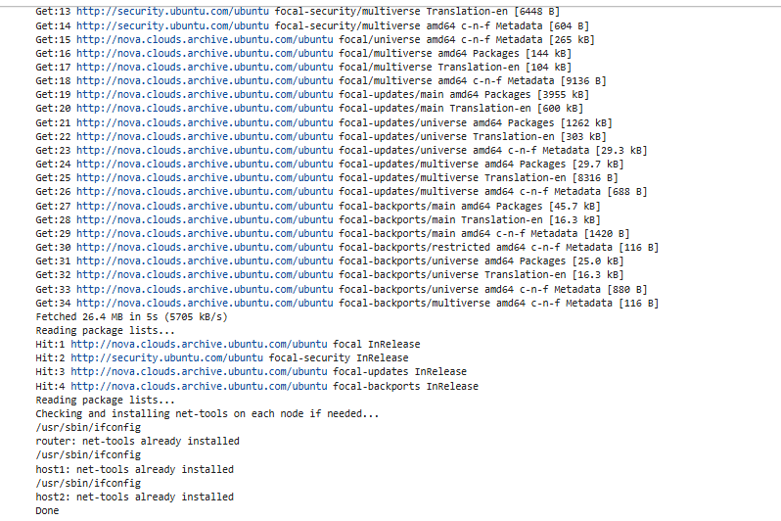
Then we continue to the Experiment: Exploring IPV6
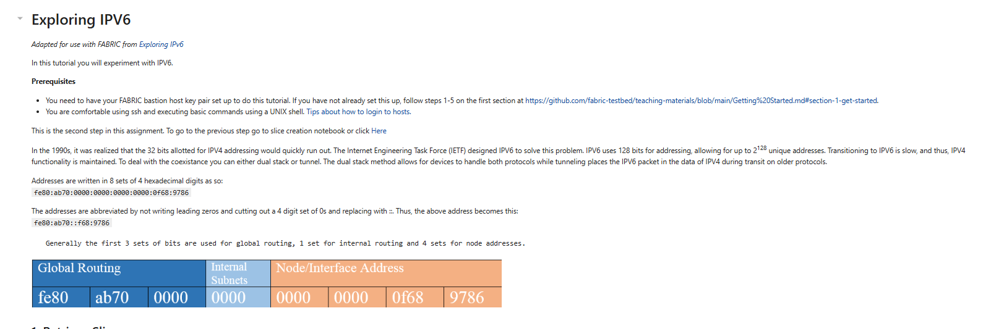

First we retrieve the slice we created
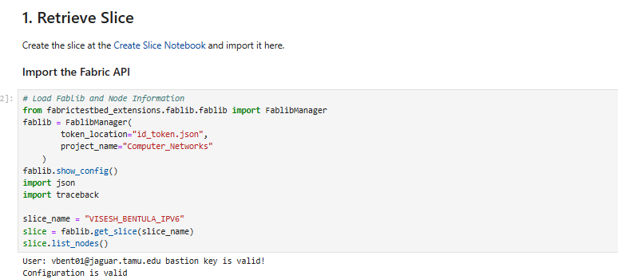
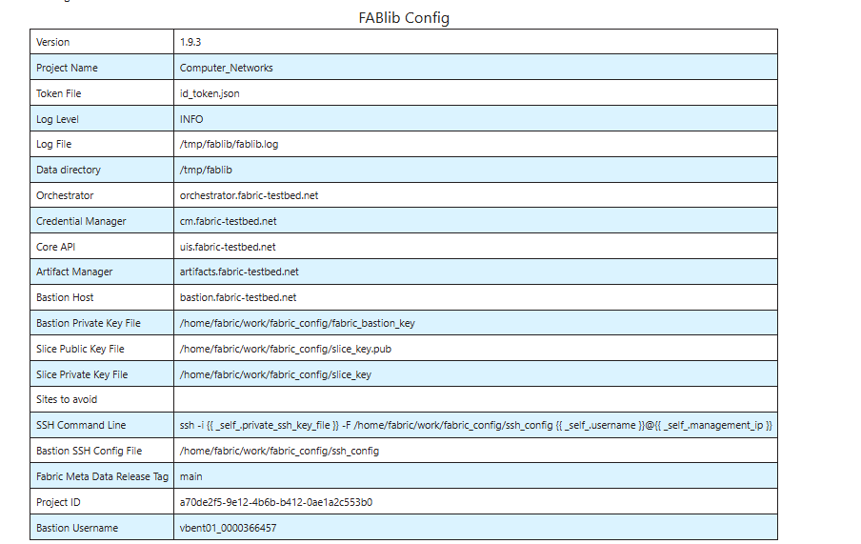
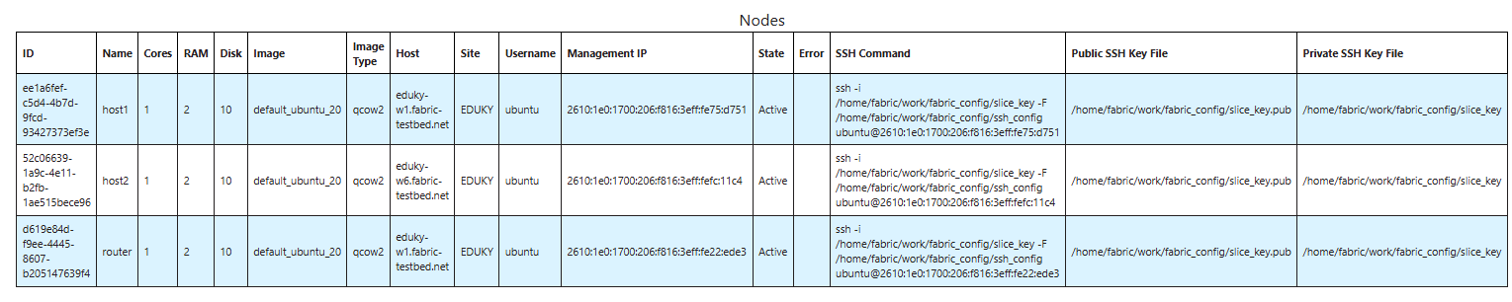
After successfully retrieving we start the exercise’s given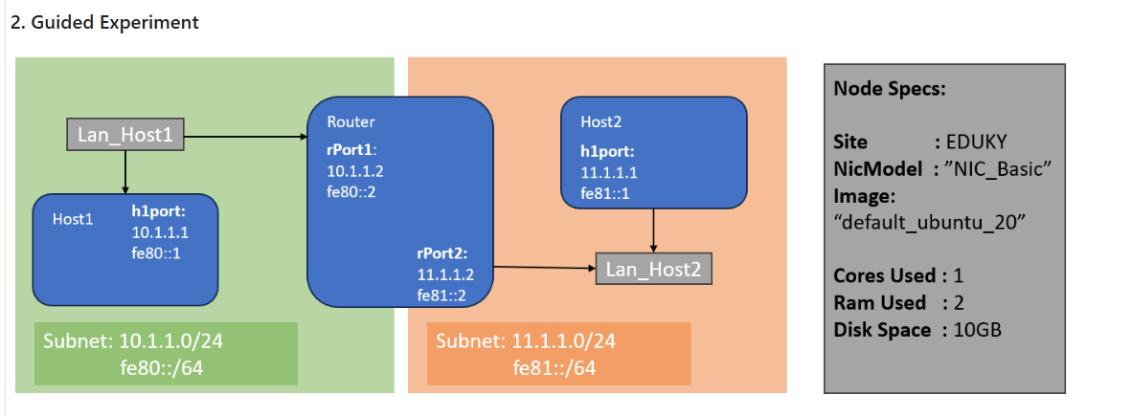

2.1 Basic Connection
We will be connecting to a node using IPV6.
- Open a terminal to all three nodes.
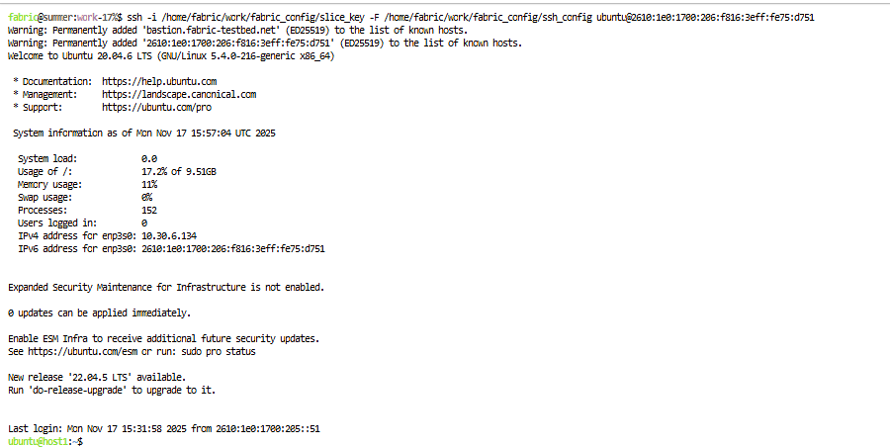
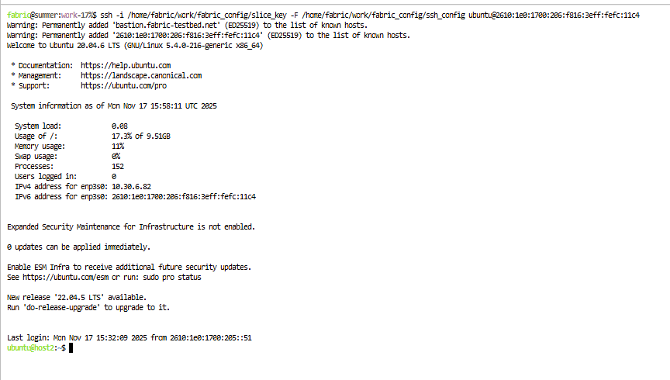
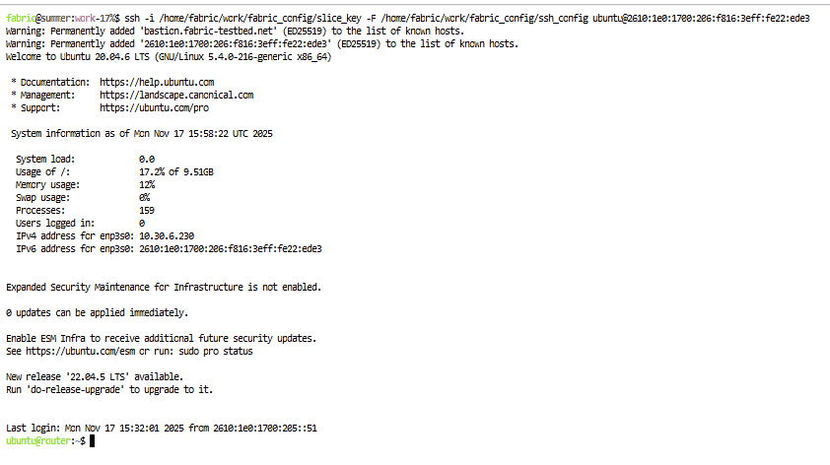
- On host1 run:
ifconfig
We can see the addresses of the interfaces. Take note of the loopback address (lo). The IPV4 address should be 127.0.0.1, and the IPV6 address should be ::1.

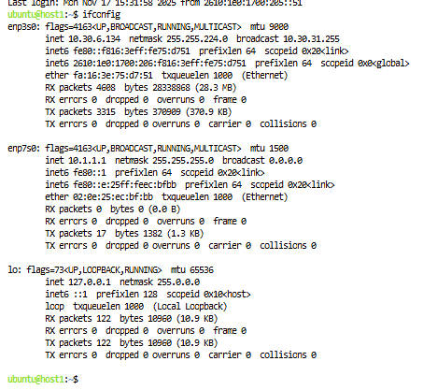
- On host1 ping host1:
Using IPV4: ping 127.0.0.1 -c 5
Using IPV6: ping6 ::1 -c 5
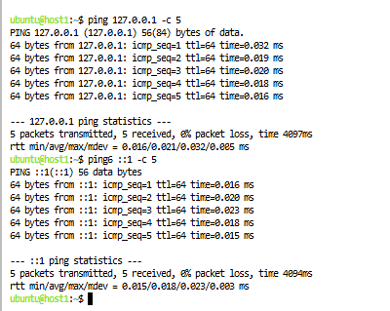
- Ping the multicast address to discover all link local neighbors on host1:
ping6 -I <link-name> ff02::1 -c 105
Where <link-name> is the name of the interface on a network (ex: enp7s0). This command will discover all link local neighbors. In this example, the output will be from the router node.
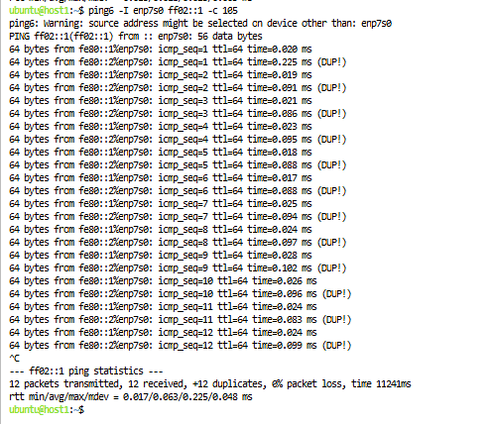

- Ping the router node from host1:
ping6 -I <link-name> <IP6-address> -c 5
The link used must be specified as in IPV6, link local addressing does not involve routing
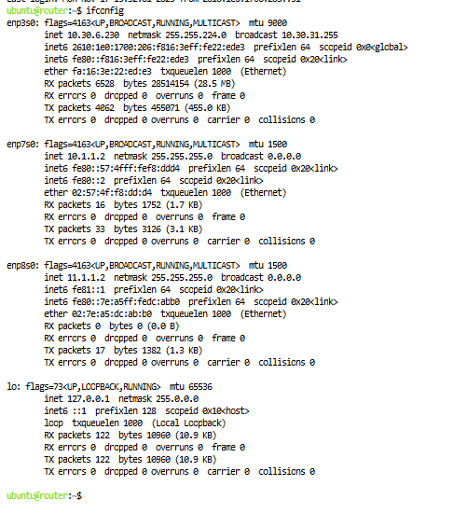
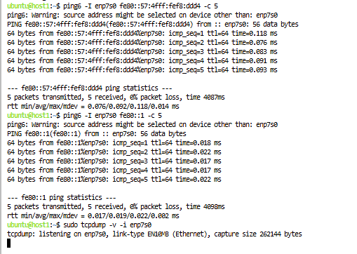
- If you try to ping host2 from host1 you will see it fails as you are using link local addressing and have not advertised any additional routes.
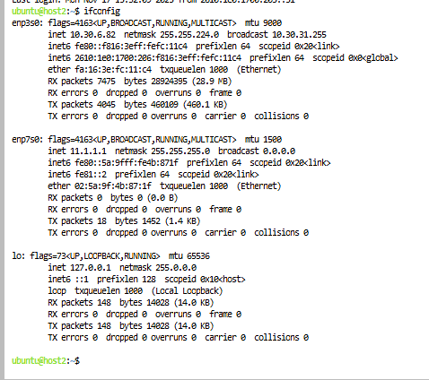
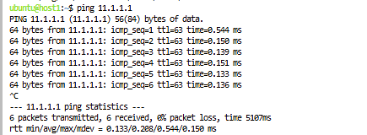

2.2 Examine Headers
We will examine the difference between IPV4 and IPV6 packets.
- On host1 startup tcpdump using:
sudo tcpdump -v -i <outgoing interface>
Where the <outgoing interface> is the interface we will be grabbing traffic from (found with ifconfig).
- On router ping host1 using IPV4:
ping 10.1.1.1 -c 5
Take note of the output on node1.

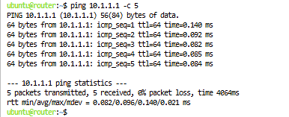
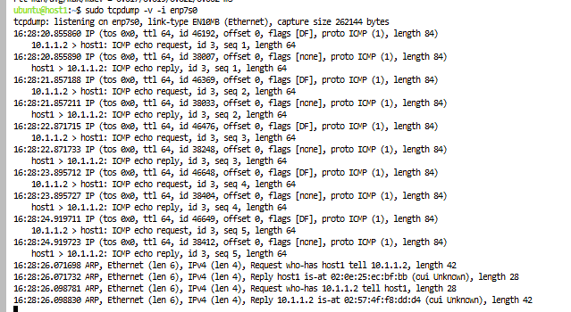
- On router ping host1 using IPV6:
ping6 -I <outgoing link name> fe80::1 -c 5
Where <outgoing link name> is the link connected to node1.
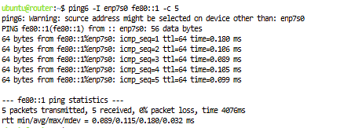
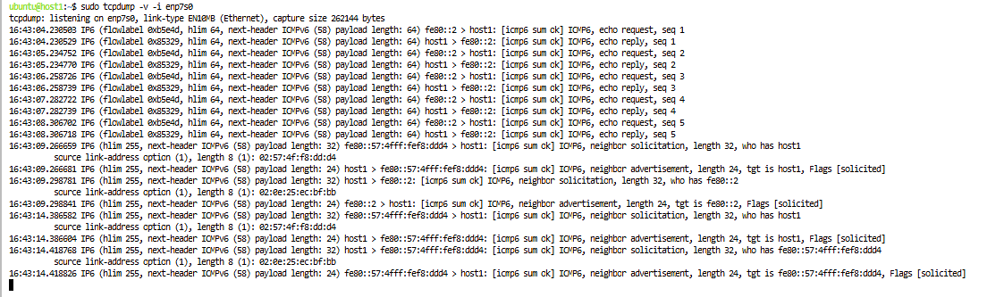
- Look at the differences in packets caught by tcmpdump:
  - IPV6 has a "flow" field, intended to be used for time important transfers
  - IPV6 headers have a standard 40 bytes. If options are needed they are pointed to in the next header field
  - Field names have been updated to better reflect their use
  - IPV6 doesn't allow for fragmentation

2.3 Use a 'Global' Type Address
We will be assigning global type interfaces to the nodes so that they can be pinged without specifying an interface.
- Choose an address for host1 (suggested to use the range 2001:0db8::/32 which has been set aside for tutorials and documentation) and run:
sudo ip -6 addr add <ip6-address>/64 dev <outgoing-link-name>
Remember that global unicast addresses begin with 001 in the first three bits. Additionally, do not worry about overlap as this address is not facing the internet.
- Ping the address you just set from host1 (pinging host1):
ping6 <ip6-address> -c 5
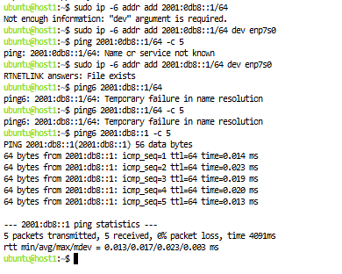
- The address isn't advertised yet. Verify on host1 with:
ip -6 route
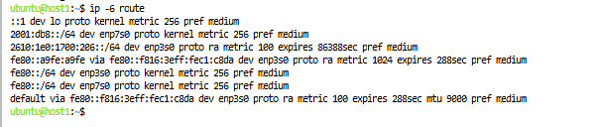
- Setup route to be advertised. On host1:
sudo ip route add <truncated-ip6-address>/64 dev <outgoing-link-name>
An example of: <truncated-ip6-address> if you chose 2001:db8::1 as your address, then you would use 2001:db8::/64 as your truncated address
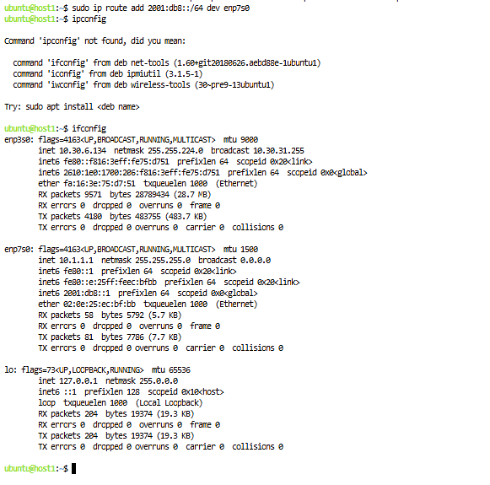
- Run through steps 1-4 on the router node using a different ip
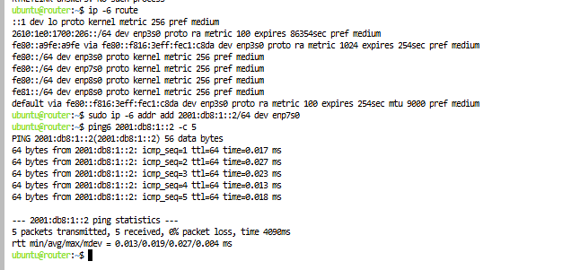
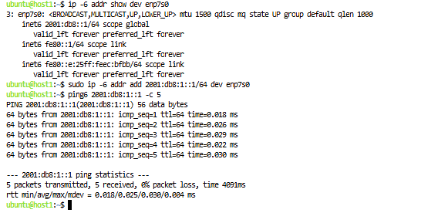

3. Assignment
Part 1
Take a look at part 2.3 in the Tutorial. Set up the third node with a global address and set the routing information so you can ping freely between the nodes. If turning this in for a grade, specify what commands you used and why, and what the resulting routing tables looked like.
Choose an address for host2
Which is: sudo ip -6 addr add 2001:db8:1::3/64 dev enp3s0
Verify route using the ip -6 route
Ping from router to host2
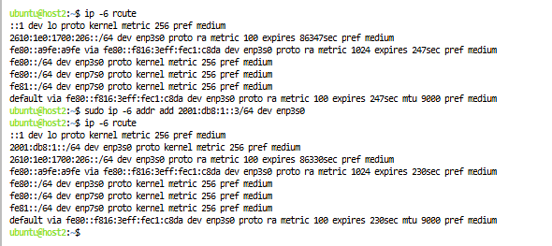
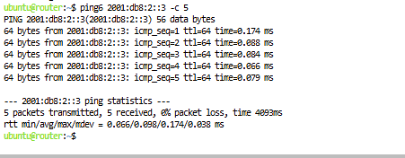

Part 2
Return to section 2.2. Repeat the experiment and see what other differences you can find in the headers. See if you can match each piece of the header you find to the pieces in the diagrams of the two header types below. You will probably not see each field come up in the tcpdump output.
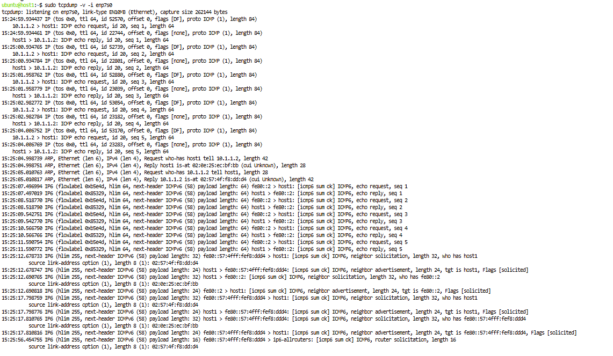
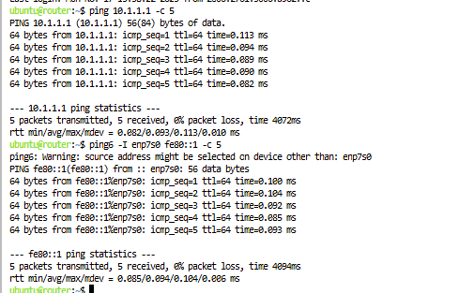

Question 1: What other major differences do you notice between the two headers?
IPv4 has a lot more fields in its header, like Identification, Flags, Fragment Offset, and a checksum. IPv6 simplifies things by using a fixed 40-byte header that only includes the essentials, such as the Flow Label, Next Header, and Hop Limit. I also noticed that IPv4 relies on ARP to find MAC addresses, while IPv6 uses Neighbor Discovery instead. IPv6 doesn’t use broadcast at all it replaces it with multicast. Another big difference is the size of the addresses IPv4 uses 32-bit addresses while IPv6 uses 128-bit addresses.
Question 2: IPv6 does not include a checksum field. Why is this field not necessary? In what major cases does this save time?
IPv6 doesn’t need a checksum because data integrity is already handled at other layers, like Ethernet and TCP or UDP. That means routers don’t have to stop and recalculate it at every hop like they do in IPv4. Removing it makes forwarding faster and reduces processing time, which helps performance especially in high-speed networks.
Question 3: What are the advantages of a fixed-length header over a variable-length header?
A fixed-length header is easier and faster for devices to process because it’s always the same size and structure. Routers don’t have to waste time figuring out where optional fields are or how long the header is. This leads to better performance, especially for hardware and high-speed networks.
Question 4: Why might IPv6 not support fragmentation?
IPv6 avoids fragmentation in routers because fragmentation slows things down and can be abused for attacks. Instead, IPv6 makes the sender figure out the right packet size using Path MTU Discovery. This keeps routers simple and efficient and pushes the responsibility to the end device instead of the network.
Question 5: If an IPv6 packet is translated to an IPv4 packet (translation approach) instead of wrapped inside one (tunneling approach), what information would be lost?
A lot of IPv6-specific information gets lost during translation. This includes the flow label, traffic class, any extension headers, and the full 128-bit addresses. Multicast behavior and some security or QoS info can also be lost. Translation only keeps the basic payload and transport layer, while tunneling keeps the entire original IPv6 packet intact.

I ran the code twice to check if the slice is deleted or not
